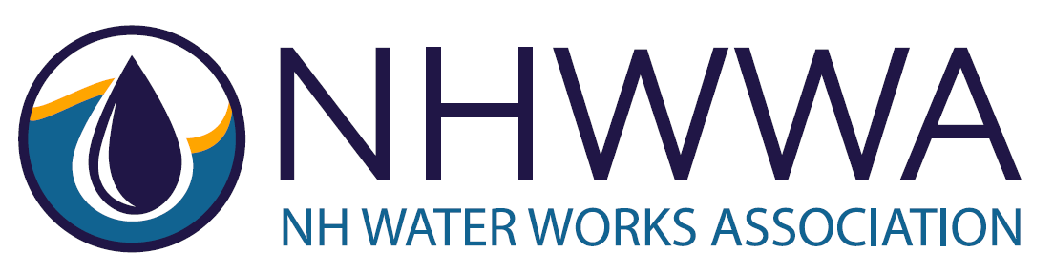

Leading Public Drinking Water Association Seeking Exemplary Candidates

President and CEO
New Hampshire Water Works Association
Concord, NH

Overview
New Hampshire Water Works Association (NHWWA) is a non-profit professional organization. NHWWA’s membership is comprised of municipal-owned, investor-owned, and privately-owned public drinking water utilities/companies representing several hundred operators and other professionals; engineers, hydrogeologists, and other consultants; materials and equipment distributors; regulators; and others in the public drinking water profession. NHWWA’s mission is to improve public water supply service in the State of New Hampshire.
Roles and Responsibilities
The President and CEO (PCEO) is responsible for oversight, management, and leadership of the Association. Typical duties include: day-to-day operation and management of the Association; organizational development and strategic planning; supervision of staff and contract employees; membership outreach and support; development and implementation of training programs; contract negotiations; budgeting and financial reporting; planning, promoting and executing events; managing social media, print and electronic communications; fundraising; governmental affairs and legislative advocacy; and other initiatives related to supporting public drinking water. The PCEO reports directly to a Board of Directors.
Experience/Qualifications
The ideal candidate will have experience in non-profit management or trade association work and proven familiarity with matters relating to public drinking water. The candidate must demonstrate an informed passion for the Association’s mission while maintaining a non-partisan, patient, and well-informed approach. The ideal candidate must have – or be able to quickly develop – working relationships with key sector leaders and partner associations.
Education: Bachelor’s degree from a recognized college or university. Preferred area(s) of study: business administration, education, environmental science, engineering, public policy, human resources, marketing, communications.
Experience: Five (5) years' experience in association leadership, including strategic planning, governance, and financial growth and management. Existing experience and relationships within New Hampshire’s public drinking water sector preferred.
Job Type: Full-time. Office located in Concord, NH. Remote work allowed.
Compensation: $75k - $90k annual salary with 2 – 4 weeks of Personal Time Off, commensurate with education and experience. Paid State and Federal holidays.
To Apply: Send resume and cover letter to info@nhwwa.org. Put “PCEO Application” in the subject line. All applications will be treated as confidential, and all applicants will be treated with respect. We anticipate filling the position in July 2023. The posting will remain open until the position is filled.

